(Approx. 1230 words)
OFFLINE MAPS FOR PORTABLE DEVICES
You can download free offline maps for later use on the go where no cell tower is accessible
Part 2 of a 3-part article series
By John Krout, Presenter & Newsletter Contributor
Potomac Area Technology and Computer Society
https://www.patacs.org
jkrout.apcug.presenter (at) gmail.com

INTRODUCTION

In Part 1 of this series, you learned why offline maps are useful on portable devices. First, they make map apps useful in areas with no available cell tower service, including almost all mountainous areas in the US, since mountain ridges block sightlines to distant cell towers. Second, where cell towers exist, you can reduce the amount of data downloaded to your phone because online maps require constant updating via cell towers as you travel.

You also learned that three map apps could use offline maps: hybrid, offline-only, and online+.

Finally, you learned where and how to download accurate offline US maps for hybrid-type apps.

Part 2 focuses on the Locus Map app, a hybrid type app that can use both offline and online maps. Locus Map is available for Android devices. Part 3 will focus on Google Maps, an online+ type app, able to download and use portions of its own online maps, and Maps.me, a strictly offline maps app. Those two apps are available for Android and iOS devices.

COPY THE DOWNLOADED MAP FILES TO YOUR PORTABLE DEVICE
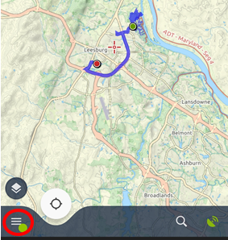
Creating or choosing a named folder on your Android portable device is important where you place the downloaded offline maps. Ideally, choose a folder name to clearly identify the folder contents.

I created a folder named MapsForge v5 Maps on my smartphone microSD card. For instance, folder creation can be done when the smartphone is connected to the computer, using Windows File Explorer. I chose that folder name so that the nature of the contents of that folder was very clear to me. Then, I copied the offline maps from my personal computer to that new folder. You can also use File Explorer to copy the downloaded map files to the new folder on the microSD card.
Illustration 1

For the discussion of the Locus Map below, this article assumes you have downloaded offline maps and copied them to a single directory of your portable device. Using these maps in Locus Map involves two steps: (1) configure the app to find the offline maps, which you need to do only once, and (2) select an offline map to display in the app.

OFFLINE MAPS AND LOCUS MAP v4.1.1

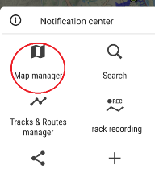
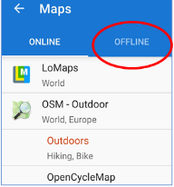
The Locus Map main screen is shown in Illustration 1. On that screen, tap the three-line Menu icon in the lower-left corner to reveal the Menu screen. The Menu icon is circled in the illustration.

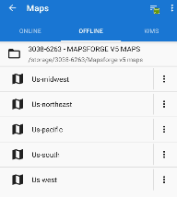
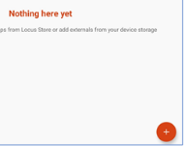
The Menu is shown in illustration 2. In that display, tap the Map Manager choice in the upper left corner to see a map selection screen. The Maps Manager choice is circled in the illustration.
Illustration 2
Illustration 3

The Map selection screen is shown in illustration 3. The screen is organized into tabs. By default, the screen offers a list of ONLINE maps that can be used in Locus Map. In that screen, tap the OFFLINE tab in the top center to see a list of available offline maps. The OFFLINE tab is circled in the illustration.
Illustration 4
Illustration 5

Here I must mention a few conflicting experiences that turn out to be important. On my Samsung Galaxy S10 smartphone, running Android 10, the offline maps I had placed in the microSD card Mapsforge v5 Maps folder were listed In the Offline tab immediately, with no effort my part to identify the offline maps folder. You can see the list of offline maps in illustration 4.

If your Offline tab lists offline maps when you first examine it, you can skip the discussion below. Instead, tap a map name in the Offline tab to begin using the map.

That did not happen on my Galaxy Tab S5e running Android 10 or my Galaxy S7 phone running Android 9. In both cases, the Offline maps tab listed no offline maps. That empty Offline tab appears in illustration 5. The red letters say Nothing here yet.

If your Offline tab lists no offline maps, here is how to identify the maps folder within Locus Map, which is the one-time-only configuration step.

In your empty Offline tab, you will find in the lower right corner of the screen a + button. Tap the + button to begin browsing to the correct offline maps folder. Note, the button is blue on my Galaxy S10 phone, and on my Galaxy Tab S5e, the button is orange. The change might be due to the Android OS version difference between my two devices. The tablet runs version 10, and the phone runs version 8.
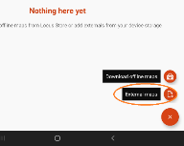
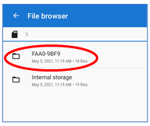
The screen adds buttons in the lower right corner, as shown in illustration 6. First, tap the External Maps button, which is circled in the illustration.

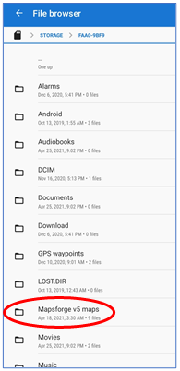
A second Nothing here yet screen appears. Tap the + button in the lower right corner.
Illustration 6
Illustration 7

The Locus Map File Browser appears, as shown in illustration 7. The File Browser initially displays two top-level folders, Internal Storage and a 9-character name, which is circled in the illustration. That circled name identifies the microSD card. The name differs from one Android device to the next. It might be a serial number for my microSD card. It is likely to be a different name on your Android phone or tablet. If you stored the offline maps in a microSD card folder, then tap that microSD card name. If you stored the offline maps in a folder in internal storage, then tap internal storage.

The contents of the storage appears, as shown in illustration 8. Again, I tapped the microSD card name. The Mapsforge v5 map folder I created is circled in the illustration.

Tap the folder name containing offline maps.

The File browser shows the folder's contents: the offline map files, as shown in illustration 5. Next, tap the check-mark button in the bottom right corner of the screen, which is not shown in the illustration.
Illustration 8

The File Browser disappears, and the selected folder containing offline maps is added to the Offline tab in the map selection screen.

If the map names are not immediately available in the Offline tab, tap on the folder name to see a list of offline maps. It will look like the list shown in Illustration 5.

USE LOCUS MAP TO OPEN AN OFFLINE MAP

To use an offline map in Locus Map, open the main menu, select the Map Manager, select the Offline tab, and view the list of offline maps. Then, tap any map name to begin using that map.

This ends part 2 of this article series. In part 3, you will learn about downloading and using offline maps in the Google Maps app and how to use the Maps.me app.

ABOUT THE AUTHOR: John Krout has been writing about the uses of personal computers since the early 1980s and is a frequent contributor to PATACS Posts, the newsletter of the Potomac Area Technology and Computer Society. He also occasionally demonstrates interesting uses of personal computers or smartphones at PATACS meetings. As of the end of 2019, before the pandemic started, his travels have included 48 US states, Europe, and South America.

